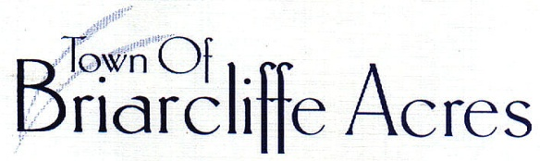
Waste and Recycling in the Town of Briarcliffe Acres

New procedures were put in place in July 2016 and communicated to all residents at that time. The Town’s contract with Waste Industries for waste and recycling expired in the summer of 2016. All haulers in the county were contacted and only Waste Industries bid on the new contract. The Town signed a five-year contract with them effective August 1, 2016. The Town continues to pay for the service directly. No charges are passed on to residents. Pertinent details of the contract are as follows:

- Roll carts - Each residence is issued one grey, 96-gallon waste roll cart and one blue, 96-gallon recycle roll cart. If a resident demonstrates the need for an extra waste and/or a recycle roll cart, the Town will issue one at no charge to the resident. Typical reasons might be the presence of young children in the home or a large family. If a resident has a short-term need for an extra cart, one will be issued to them. All communication involving waste and recycling service and equipment must go through the Town office. The contract is the Town's.

- Waste is collected once/week on Mondays. Recycling is collected every other week on Mondays. Waste Industries does not provide twice per week waste pick up in any of their service areas with the exception of certain large, tourist rental properties. With the current recycling program, we are exceeding the ratio of recycling to total waste as targeted by the Solid Waste Authority. Recycling dates are noted on your calendar.

- If waste exceeds the capacity of the container, you are allowed to place up to three kitchen garbage bags on top of the waste roll cart.

- If you believe your waste will exceed capacity due to holidays, large parties or functions, you may contact the Town office for the use of an extra cart(s) for short term. The Town maintains an inventory of extra roll carts on site.

- Cardboard - Residents are encouraged to fold card board and place it on top of recycling containers to more efficiently make use of the capacity of the recycle cart.

- Damaged carts will be picked up and a new cart will be issued upon request at no charge. Contact the Clerk.

- Back Yard Pickup - This service was instituted with the new contract in 2016. It is reserved for residents who find it physically difficult to handle the full roll carts; you may contact the office to inquire about the service. Currently, 13 families take advantage of this service. The cart(s) should be placed in view of the road/outside garage - the carts will be picked up, emptied, and returned to the home by the drivers.

- Placement of roll carts for pickup - For the convenience of residents, we amended the waste and recycling ordinance in 2017 to allow placement of roll carts at road side after 5 pm the day before scheduled pickup. Carts should be taken away from the road by 8am the day after pickup.

Office Of Town Clerk 121 North Gate Road Myrtle Beach, South Carolina 29572 843.272.8863

